Epics Purdue; Fall 2019; Project team Wolf

Wolf Park Application Development Guide
Author: Adam Popper; apopper@purdue.edu

Abstract:
This document will cover information pertaining to the maintenance and continued development plans for the application built for the Wolf park interactive map kiosk application. We will start by we will go over general information about the application operations during regular operation. Then we will go into the progress of development up to the end of Fall 2019 semester. Finally we will discuss the future development plans of the application and proposed methods of implementation.

Table of Contents:
Abstract……………………………………………………………………………………………… 1
Introduction ……………....…………………………………………………………………………. 3
Introduction to the Application……………………………………………………………... 3
Introduction to the Hardware………………………………………………………………. 3-4
Getting started …………………………………………………………………………………….... 5-6
Application.py ………………………………………………………………………………. 5
Interface.py …………………………………………………………………………………. 5
Gpio_interface.py ………………………………………………………………………….. 5-6
Future Development …..……………………………………………………………………………... 7
Map Build Engine…………………………………………………………………………… 7
Furthering Current Build .…………………………………………………………………… 7

Introduction:
Introduction to the Application:

In this section we will go over all of the components of the kiosk application and explain what the look like when the system is all working.

Component list:
- Raspberry Pi: This is the on board computer allowing low level graphics output and runs that application
- Project folder “WOLF_PY”: this can be found on the desktop of the raspberry pi or on the Fall 2019 software leads git: https://github.com/poppeada000/Wolf_PY

Functionality:
When the device gets plugged in, the raspberry pi should boot up to the application removing any mouse and keyboard functionality. Once the application boots, click the buttons, which should allow you to change from one page to the next and then finally times out any page after 20 seconds of being on it. The last part of the application is the maintenance button on the inside of the kiosk, this should close the application and bring you to the device desktop for maintenance.

Introduction to the Hardware:

In this section we will go over all of the components of the kiosks electrical hardware and explain what interactions look like when the system is all working.

Component list:
- Raspberry Pi: This is the on board computer allowing low level graphics output and runs that application
  - Needed supply voltage of 5V
- Content Buttons: These buttons after boot will allow the application to switch from one content page to the next using the GPIO pins.
  - Voltage supplied by GPIO pins
  - For wiring guideline visit page
- Main Screen: This is the main display screen that is connected to the raspberry pi through an hdmi connector.
  - Power is supplied by separate power block on distribution board
- Power Distribution Board: This is the main powerstrip supplying power to the entire kiosk
  - This will act as main power control and will need to be connected to a wall outlet.

Functionality:
When the device gets plugged in, the raspberry pi should boot up to the application. You should see the main display power up and see a boot running on the main screen. Once the application boots, click the buttons, which should allow you to change from one page to the next and then finally times out any page after 20 seconds of being on it. The last part of the application is the maintenance button on the inside of the kiosk, this should close the application and bring you to the device desktop for maintenance.

Getting Started:
Application.py:
Required Concepts:
- Regular Expressions (‘re’ module in python)
- Object Oriented Python Programming

This script is designed to import all of the content and images from the text documents and using regular expressions refines the pulled text into its respective bins. This script will get called by Interface and sets what sections could be set on the content pages.

Interface.py:
Required Concepts:
- PyGame python Module experience
  - Similar to programming graphics is Javascript
- SDL Graphics Rendering Concepts
  - Just methodology
- Object Oriented Programming in Python
- Knowledge of python data structures
  - Lists, sets, dictionaries….
This script is designed to handle the assembly and rendering of the application pages. It will take the output of application.py and run a series of filtering procedures that will sort all individual components of the pages into an unordered list that has each section being a different content page with all contents built and ready to be rendered in real time.

Gpio_interface.py:
Required Concepts:
- Knowledge of GPIO pins
  - Understanding high/low
- Time module in python
  - How to use as timer and stopwatch
- Understanding of how to invoke Interface.py to render
  - As well as what specifically to render

This script is designed to act as the main button interface between the kiosk users and the Raspberry pi’s operating system. Below is a copy of the pinout with the markings of which button to connect where.
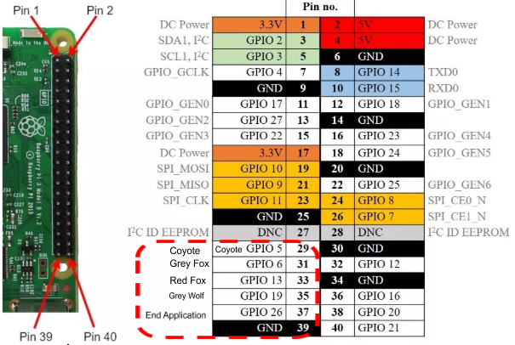

Future Development:

Map Build Engine:
The map build engine is designed to import statically stored data in the application src files. This would be done using the matplotlib module.

Furthering Current Build:
Fall 2019 (ideas):
- Check the system for screen timeout.
- Map Build Engine
- Maps added to content pages.
- Change background of content pages
- Over the air application updates
- Playing audio on content screens

